Compile-time Polymorphism (Method Overloading)

Program:

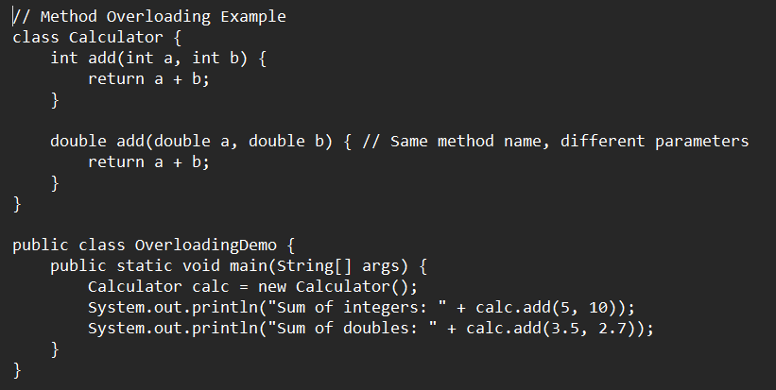

Output:



Runtime Polymorphism (Method Overriding)

Program:

Output:

